|  |  |  |
| --- | --- | --- |
|  |  | This document  Has been edited with LibreOffice Online |

April 2016

# How to start Using the cloud

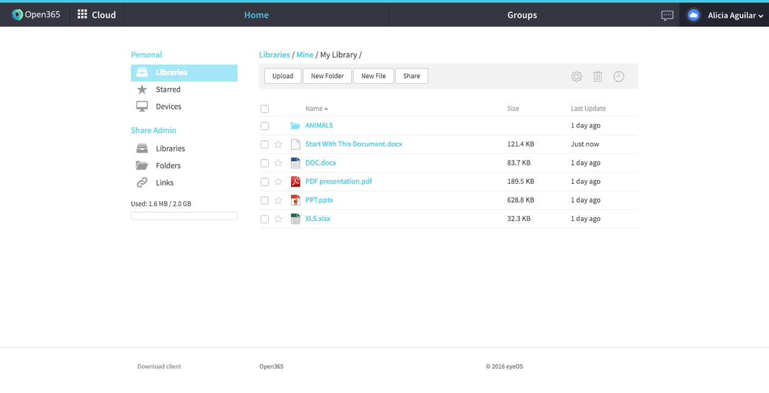



You can launch all your applications from the menu located in the left of the top-bar.



# OTHER FUNCTIONALITIES

## The chat

To start chatting with people just click on the icon at the upper right side of the page.

## Open365%20Chat2.png

## The Videoconference



Click on “**Start Videoconference”** inside the chat screen to start a videoconference with the person you are chatting with.

## Looks good right?

Wait until you see the rest of our productivity suite ☺

## Open365%20Hub.pngThe hub

library.pngThe Hub is a place for you to start uploading and sharing files. To upload files, first you need to select your folder by clicking on your desired library. We have created a default folder for you:

After that just drag the files from your desktop and drop them on this screen or just click on the button that says on the bar.

# How to start writing

To start writing, just click wherever you want (like here for example) and start typing.

## Inserting Images

You can add any images you want…

## Or you can play with shapes

Try to resize me!